CAPFAA Virtual Conference Agenda

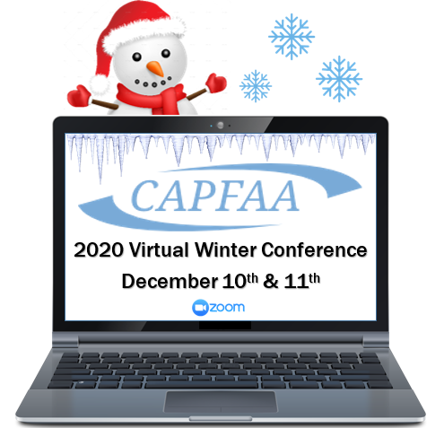

Thursday Afternoon, December 10th, 1 pm to 6:00 pm
1:00 -1:15
Opening Remarks & National Anthem
1:15 – 2:15
KeyNote - Motivational Speaker Please do not mute yourself to allow for audience interaction!!
In this interactive and engaging presentation, you’ll enjoy clean humor and show business anecdotes to drive home the importance of energy, attitude, and motivation. These skills are crucial to success in any venture, whether your focus is on Leadership, Teamwork, Customer Service, Change, Stress Reduction, or simply Having More Fun at Work.
Larry Weaver delivers clean, positive humor worldwide through stand-up comedy, motivational speaking, and digital media. After majoring in accounting at the University of North Carolina, Larry left his CPA dreams behind to pursue a career in public speaking. He has delivered keynotes at over 1,000 events in 39 states, sharing the stage with entertainment legends like Faith Hill, Chris Rock, and "Weird Al" Yankovic. Businesses from over 60 countries - from Mozambique to Malta - have purchased his book "101 Funny Employee Awards". You can hear Larry’s clean humor daily on SiriusXM satellite radio's "Laugh USA" and "Blue Collar Radio."
Sessions
2:30 -3:30 45 minute session 15 for questions
Pandemic Professional Judgments: Balancing Student Needs, Compliance, and Administrative Burden Tony Erwin, Blue Icon & Sage Stachowiak, Southern CT State
Professional judgment requests are on the rise. So are stress levels from students, families, and financial aid staff. How do you balance 1) following published guidance, 2) requesting the appropriate amount of documentation, and 3) providing good customer service? This session will review the options available to help students through professional judgment and provide strategies for managing difficult situations.
3:45 -4:30
The Leadership Secrets of Santa Claus Deb Glenn-Long
It isn’t easy being Santa Claus. Relying on a workshop full of elves, a small group of reindeer (who don’t always play well together) and an all-terrain sleigh to get the latest, greatest toys delivered to the good little boys and girls all over the world…during a pandemic no less. How will he do it? From reindeer recruitment to assessing the demands for little red wagons versus the latest electronic gizmos and gadgets, Santa certainly has his hands full. Is it possible that Santa’s eight leadership secrets can make your workshop equally effective and just as much fun? Tune in to learn what it is that gives Santa the energy to carry the sack, lead the pack and keep coming back!
4:30 -6:00 ish
Virtual Happy Hour with Kahoot
Live interactive game played on a shared screen! Test your knowledge of CT Institutions and our Business Partners who support us, CAPFAA History, and maybe a regulation or two!
Prizes for the Top Three Winners!!!
Friday Morning, December 11th, 8:30 am to 1 pm
8:30 - 9:30 - Morning Stretch and Meditation with Soul Squad Yoga - All you need is a mat and some comfy clothes!
www.soulsquadyoga.com
Sessions
9:45 -10:15 - Cyber Breakfast and Researching Regulations
Join Peter Terebesi and Ralph Brasure as they provide a “Year in Review – 2020” along with information about the day’s food menu selections. Come and be with us as we do a “live” Cyber Brunch.

10:30 – 11:30 - Student Loan Repayment Strategies for your Students (Panel) A forum discussing private student loans, repayment, and refinancing.
11:45 – 12:15 - Industry updates from the State of Connecticut, and EASFAA - Mark French, Shawn Morrissey
12:30 – 1:15 - Federal/NASFAA Update – Megan (McClean) Coval
1:15 – 2:00 - CAPFAA Business Meeting & Presentation to Award Recipients

